INTERNSHIP REPORT

A report submitted in partial fulfillment of the requirements for the Award of Degree of

BACHELOR OF TECHNOLOGY
In
COMPUTER SCIENCE AND ENGINEERING
By
R K SPANDANA Regd. No.: 16A51A0571
Under Supervision of Questease Solutions,
Hyderabad.
(Duration: 13th May, 2019 to 10th June, 2019)



DEPARTMENT OF COMPUTER SCIENCE AND ENGINEERING
VIT BHOPAL UNIVERSITY
2026– 2027

DEPARTMENT OF COMPUTER SCIENCE AND ENGINEERING
VIT BHOPAL UNIVERSITY

CERTIFICATE

This is to certify that the “Internship report” submitted by R. K. SPANDANA (Regd. No.: 16A51A0571) is work done by her and submitted during 2020 – 2021 academic year, in partial fulfillment of the requirements for the award of the degree of BACHELOR OF TECHNOLOGY in COMPUTER SCIENCE AND

ENGINEERING, at Questease Solutions, Hyderabad.

College Internship Guide
Name & Designation

CERTIFICATION

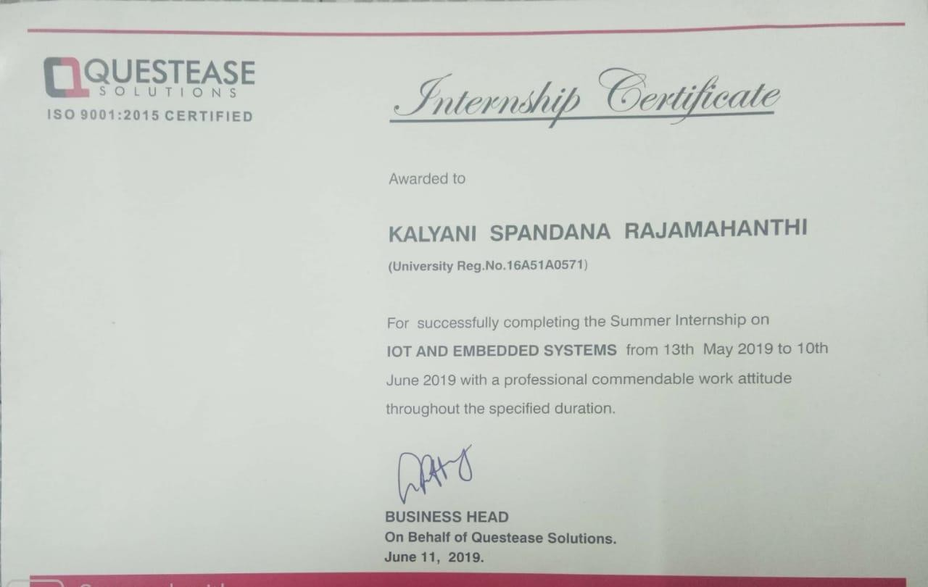

ACKNOWLEDGEMENT

First I would like to thank the Director of Questease Solutions, Hyderabad for giving me the opportunity to do an internship within the organization.

I also would like all the people that worked along with me in Questease Solutions, Hyderabad with their patience and openness they created an enjoyable working environment.

It is indeed with a great sense of pleasure and immense sense of gratitude that I acknowledge the help of these individuals.

I am highly indebted to Dean Dr.Manas Kumar Mishra, for the facilities provided to accomplish this internship.

I would like to thank my Program Chair Dr. M.Ashwin for his constructive criticism throughout my internship.

I would like to thank Dr. J.Amudhavel, for his support and advices to get and complete internship in above said organization.

I am extremely great full to my department staff members and friends who helped me in successful completion of this internship.

R. K. SPANDANA (16A51A0571)

ABSTRACT

Internet of Things (IoT) conceptualizes the idea of remotely connecting and monitoring real world objects (things) through the Internet [1]. When it comes to our house, this concept can be aptly incorporated to make it smarter, safer and automated. This IoT project focuses on building a “SMART HOME AUTOMATION SYSTEM” which is mainly concerned to design a system that allows users, upon authentication, to remotely control and monitor multiple home appliances using a cell-phone based interface. The leverage obtained by prefering this system over the similar kinds of existing systems is that the alerts and the status sent by the wifi connected microcontroller managed system can be received by the user on his phone from any distance irrespective of whether his mobile phone is connected to the internet. The microcontroller used in the current prototype is the TI- CC3200 Launchpad board which comes with an embedded micro-controller and an onboard Wi-Fi shield making use of which all the elctrical appliances inside the home can be controlled and managed.
Internet of things has been governing the electronics era with cloud services dominating the ever increasing electronics product segment. By using this we can switch on or off the lights or fans automatically when we are outside. This proposes a smart home automation system based on Open source cloud server “things speak.com” and a low cost esp8266 Wi-Fi module.

The System transmits an alert signal to the Open source cloud which provides a alert signal on the users mobile phone. The system employs a second esp8266 module which is programmed to act as a web server, which allows the user to activate or deactivate the security system by means of any device with internet.

Smart connectivity with existing networks and context-aware computation using network resources is an indispensable part of IoT. With the growing presence of Wi-Fi and 4G-LTE wireless Internet access, the evolution towards ubiquitous information and communication networks is already evident. However, for the Internet of Things vision to successfully emerge, the computing paradigm will need to go beyond traditional mobile computing scenarios that use smart phones and portables, and evolve into connecting everyday existing objects and embedding intelligence into our environment. For technology to disappear from the consciousness of the user, the Internet of Things demands: a shared understanding of the situation of its users and their appliances, software architectures and pervasive communication networks to process and convey the contextual information to where it is relevant, and the analytics tools in the Internet of Things that aim for

autonomous and smart behavior. With these three fundamental grounds in place, smart connectivity and context-aware computation can be accomplished.

A radical evolution of the current Internet into a Network of interconnected objects that not only harvests information from the environment (sensing) and interacts with the physical world (actuation/ command/control), but also uses existing Internet standards to provide services for information transfer, analytics, applications, and communications. Fueled by the prevalence of devices enabled by open wireless technology such as Bluetooth, radio frequency identification (RFID), Wi-Fi, and telephonic data services as well asembedded sensor and actuator nodes, IoT has stepped out of its infancyand is on the verge of transforming the current static Internet into a fully integrated Future Internet.

Methodology:
Our project aims to control or operate various equipment, machinery, industrial processes and other applications using various control systems with less or no human intervention. By using components of Power supply Board, Node MCU, 2 Channel Relay and alerting the user or the owner with a notification in the Blynk app so that the user can be able to operate if the lights or fans are left switched on.

Programmes and opportunities:
The Institute combines pioneering research with top class education. An innovative curriculum allows the student flexibility in selecting courses and projects. Students, even at the undergraduate level, get to participate in ongoing research and technology development - an opportunity unprecedented in India. As a result, a vibrant undergraduate programme co-exists with a strong postgraduate programme.

Organization Information
Questease Solutions is an initiative by Industry experts with a vision to provide practical oriented training internship programs along with Industry recognized certification supported by expert guidance to crack the job interviewsWe have trained more than 5000
+ from various colleges across Telangana, Andhra, Orissa, Chhattisgarh etc.

Questease Solutions started its career development centre in partnership with HCL Learning Ltd in Mid-June 2013 and in pursuance of our continued efforts to enhance the skills of the students, Questease Solutions from time to time gets associated with leading MNC’s to explore the various industry related opportunities for students.

With technology advancing at rapid pace, Industries are forced to adapt to the changes, which in turn impacts the recruitment industry. To cope up with the changes, professionals need to scale up their skills and come out of the academic mind-set to embrace the advancement of the technology, Questease Solutions have structurally designed the Internship keeping in view the changes of the market and accordingly customizing the programs to suit the ever-changing Industry requirements

Benefits to the company / institution through your report:

The Institute combines pioneering research with top class education. An innovative curriculum allows the student flexibility in selecting courses and projects. Students, even at the undergraduate level, get to participate in ongoing research and technology development - an opportunity unprecedented in India.

Learning Objectives/Internship Objectives

- Internships are generally thought of to be reserved for college students looking to gain experience in a particular field. However, a wide array of people can benefit from Training Internships in order to receive real world experience and develop their skills.
- An objective for this position should emphasize the skills you already possess in the area and your interest in learning more
- Internships are utilized in a number of different career fields, including architecture, engineering, healthcare, economics, advertising and many more.
- Some internships are used to allow individuals to perform scientific research while others are specifically designed to allow people to gain first-hand experience working.
- Utilizing internships is a great way to build your resume and develop skills that can be emphasized in your resume for future jobs. When you are applying for a Training Internship, make sure to highlight any special skills or talents that can make you stand apart from the rest of the applicants so that you have an improved chance of landing the position.

WEEKLY OVERVIEW OF INTERNSHIP ACTIVITIES

1st WEEK | DATE | DAY | NAME OF THE TOPIC/MODULE COMPLETED
1st WEEK | 13/5/19 | Monday | Reporting at office with all Photocopies of Documents.  Overview to Company Profile & Total Internship Schedule
1st WEEK | 14/5/19 | Tuesday | Brief Introduction on Internet of Things (IOT)
1st WEEK | 15/5/19 | Wednesday | Discuss PROS & CROS of IOT
1st WEEK | 16/5/19 | Thursday | Learning the Electronic components
1st WEEK | 17/5/19 | Friday | Learn how to connect circuits
1st WEEK | 18/5/19 | Saturday | Holiday

2nd WEEK | DATE | DAY | NAME OF THE TOPIC/MODULE COMPLETED
2nd WEEK | 19/5/19 | Monday | Holiday
2nd WEEK | 20/5/19 | Tuesday | Learning components of IOT
2nd WEEK | 21/5/19 | Wednesday | Working with components
2nd WEEK | 22/5/19 | Thursday | Holiday
2nd WEEK | 23/5/19 | Friday | Sample Projects
2nd WEEK | 24/5/19 | Saturday | Sample Projects

3rd WEEK | DATE | DAY | NAME OF THE TOPIC/MODULE COMPLETED
3rd WEEK | 25/5/19 | Monday | Holiday
3rd WEEK | 26/5/19 | Tuesday | Introduction to Blynk application
3rd WEEK | 27/5/19 | Wednesday | Configuring Blynk app with Wi-Fi
3rd WEEK | 28/5/19 | Thursday | Holiday
3rd WEEK | 29/5/19 | Friday | Sample Projects using Blynk app
3rd WEEK | 30/5/19 | Saturday | Discuss about the latest IOT projects

4th WEEK | DATE | DAY | NAME OF THE TOPIC/MODULE COMPLETED
4th WEEK | 31/6/19 | Monday | Discussion on left over Topics
4th WEEK | 1/6/19 | Tuesday | Holiday
4th WEEK | 2/6/19 | Wednesday | Holiday
4th WEEK | 3/6/19 | Thursday | Assigning Projects
4th WEEK | 4/6/19 | Friday | Implementation of Project
4th WEEK | 5/6/19 | Saturday | Implementation of Project
4th WEEK | 6/6/19 | Monday | Holiday
4th WEEK | 7/6/19 | Tuesday | Project Presentation
4th WEEK | 8/6/19 | Wednesday | Project Presentation
4th WEEK | 9/6/19 | Thursday | Submission of Project abstract & Presentation

INDEX

SNo. |  | Contents | Page
no.
1. |  | Introduction | 1
2. |  | History | 2
3. |  | Definition | 2
4. |  | Architecture of IOT | 3
5. |  | Applications | 4
6. |  | Components Used
 | 6.1 | Arduino UNO | 4
 | 6.2 | ESP8266 (Wi-Fi Module) | 4
 | 6.3 | Breadboard & Jump Wires | 5
 | 6.4 | Power Supply Board | 6
 | 6.5 | 2 Channel Relay | 6
7. |  | Blynk app | 7
8. |  | Configuring Blynk | 8
9. |  | Advantages & Disadvantages | 9
10. |  | Requirements
 | 10.1. | Software Requirements | 10
 | 10.2 | Hardware Requirements | 10
11. |  | Project Implementation | 10
12. |  | Source Code | 11
13. |  | Circuit Connections | 14
14. |  | Output | 15
15. |  | Conclusion | 15
16 |  | Bibliography & References | 16

- INTRODCTION TO INTERNET OF THINGS (IoT)

Anyone who says that the Internet has fundamentally changed society may be right, but at the same time, the greatest transformation actually still lies ahead of us. Several new technologies are now converging in a way that means the Internet is on the brink of a substantial expansion as objects large and small get connected and assume their own web identity.

Following on from the Internet of computers, when our servers and personal computers were connected to a global network, and the Internet of mobile telephones, when it was the turn of telephones and other mobile units, the next phase of development is the Internet of things, when more or less anything will be connected and managed in the virtual world. This revolution will be the Net’s largest enlargement ever and will have sweeping effects on every industry — and all of
our every day lives.

Smart connectivity with existing networks and context-aware computation using network resources is an indispensable part of IoT. With the growing presence of Wi-Fi and 4G-LTE wireless Internet access, the evolution towards ubiquitous information and communication networks is already evident. However, for the Internet of Things vision to successfully emerge, the computing paradigm will need to go beyond traditional mobile computing scenarios that use smart phones and portables, and evolve into connecting everyday existing objects and embedding intelligence into our environment. For technology to disappear from the consciousness of the user, the Internet of Things demands: a shared understanding of the situation of its users and their appliances, software architectures and pervasive communication networks to process and convey the contextual information to where it is relevant, and the analytics tools in the Internet of Things that aim for autonomous and smart behavior. With these three fundamental grounds in place, smart connectivity and context-aware computation can be accomplished.

A radical evolution of the current Internet into a Network of interconnected objects that not only harvests information from the environment (sensing) and interacts with the physical world (actuation/ command/control), but also uses existing Internet standards to provide services for information transfer, analytics, applications, and communications.
Fueled by the prevalence of devices enabled by open wireless technology such as Bluetooth, radio frequency identification (RFID), Wi-Fi, and telephonic data services as well as embedded sensor and actuator nodes, IoT has stepped out of its infancy and is on the verge of transforming the current static Internet into a fully integrated Future Internet.

HISTORY

In early 1982 the concept of the network of smart devices was discussed, with a modified Coke machine. This coke machine is modified at “Carnegie Mellon University” and becoming the first Internet-connected appliance. This machine was able to report its inventory and whether newly loaded drinks were cold.

In 1994 Reza Raji explained the idea of IoT as “small packets of data to a large set of nodes, so as to integrate and automate everything from home appliances to entire factories”. After that many companies proposed various solutions like Microsoft’s at Work or Novell’s Nest. Bill Joy proposed Device to Device (D2D) communication as a part of his “Six Webs” frameworks at the World Economic Forum at Davos in 1999.

The thought of Internet of Things first became popular in 1999. British entrepreneur Kevin Ashton first used the term Internet of Things in 1999 while working at Auto-ID labs. Besides that near field communication, barcode scanners, QR code scanners and digital watermarking are the various devices which are working on IoT in the present scenario.

DEFINITION

“Today computers and the Internet are almost wholly dependent on human beings for information. Nearly all of the roughly 50 petabytes (1 petabyte=1015 bytes) of data available on the Internet were first captured and created by human beings by typing, pressing a record button, taking a digital picture, or scanning a bar code. Conventional diagrams of the Internet leave out the most numerous and important routers of all - people. The problem is, people have limited time, attention and accuracy all of which means they are not very good at capturing data about things in the real world. And that's a big deal. We're physical, and so is our environment … You can't eat bits, burn them to stay warm or put them in your gas tank. Ideas and information are important, but things matter much more. Yet today's information technology is so dependent on data originated by people that our computers know more about ideas than things. If we had computers that knew everything there was to know about things using data they gathered without any help from us we would be able to track and count everything, and greatly reduce waste, loss and cost. We would know when things needed replacing, repairing or recalling, and whether they were fresh or past their best. The Internet of Things has the potential to change the world, just as the Internet did or even more.

ARCHITECTURE OF INTERNET OF THINGS

Architecture of internet Of Things contains basically 4 layers:

- Application Layer
- Gateway and the network layer
- Management Service layer
- Sensor layer

APPLICATION LAYER:

- Lowest Abstraction Layer
- With sensors we are creating digital nervous system.
- Incorporated to measure physical quantities
- Interconnects the physical and digital world
- Collects and process the real time information

GATEWAY AND THE NETWORK LAYER:
- Robust and High performance network infrastructure
- Supports the communication requirements for latency, bandwidth or security
- Allows multiple organizations to share and use the same network independently

MANAGEMENT LAYER:
- Capturing of periodic sensory data
- Data Analytics (Extracts relevant information from massive amount of raw data)
- Streaming Analytics (Process real time data)
- Ensures security and privacy of data.

SENSOR LAYER:

- Provides a user interface for using IoT.
- Different applications for various sectors like Transportation, Healthcare, Agriculture, Supply chains, Government, Retail etc.

APPLICATIONS

There are several application domains which will be impacted by the emerging Internet of Things. The applications can be classified based on the type of network availability, coverage, scale, heterogeneity, repeatability, user involvement and impact.
We categorize the applications into four application domains:
- Personal and Home
- Enterprise
- Utilities
- Mobile

There is a huge crossover in applications and the use of data between domains. For instance, the Personal and Home IoT produces electricity usage data in the house and makes it available to the electricity (utility) company which can in turn optimize the supply and demand in the Utility IoT. The internet enables sharing of data between different service providers in a seamless manner creating multiple business opportunities.

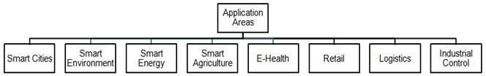

Components Used

Arduino Uno

Arduino is an open source, PC paraphernalia and programming organization, endeavour, and client group that plans and produce microcontroller packs for constructing programmed devices and intelligent object that can detect and control questions in the real world. The inception of the Arduino extend began at the Interaction Design Institute in Ivrea, Italy. The equipment reference plans are appropriated under a Creative Commons Attribution Share.

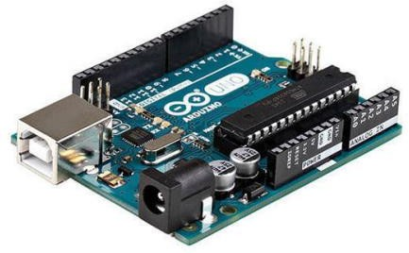

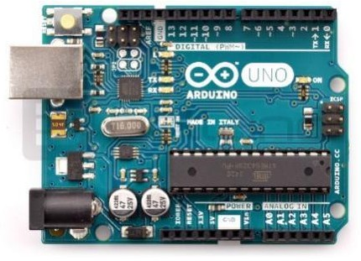

ESP8266 (WiFi Module)

The ESP8266 is an ease Wi-Fi chip with full TCP/IP stack and MCU (Micro Controller Unit) capacity created by Chinese . These are the primary arrangement of modules made with the ESP8266 by the outsider producer AI-Thinker and remain the most generally available. They are large alluded to as "ESP-xx modules". To shape a workable advancement framework they require extra parts, particularly a serial TTL-to-USB connector and an outside 3.3 volt control supply.

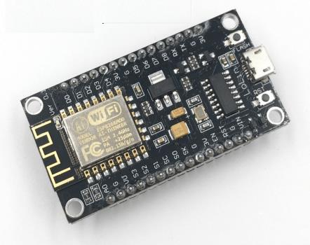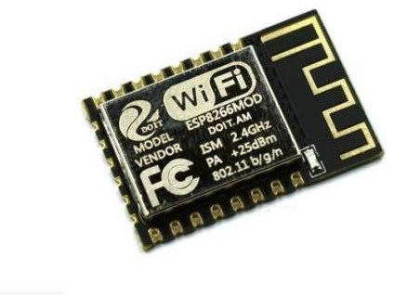

Bread board and Jump wires
A breadboard is utilized to build and test circuits expeditiously afore finalizing any circuit design. The breadboard has many apertures into which route components like ICs and resistors can be connected. The apertures are generally spaced 0.1“ apart to put up standard DIP machinery. A typical breadboard that includes top and bottom power distribution rails.Jump wires are generally used to establish connectivity with bread board.
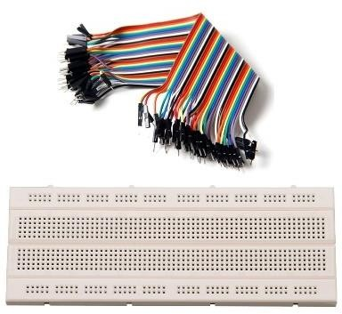
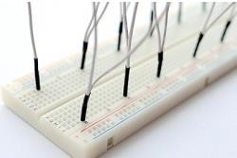

Power SupplyBoard

Modern Arduino Uno boards allow the board to have more than one source of power to be connected simultaneously. An intelligent switching circuitry ensures that the highest available voltage is selected and sent to the onboard voltage regulator and eventually powers up the board.
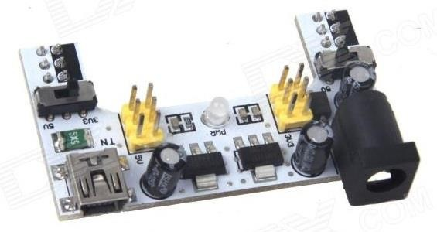

2- Channel Relay

A relay is an electrically operated switch and is frequently used in automatic control circuit. Relays are used where it is necessary to control a circuit by a low-power signal. Relays protect electrical circuits from overload or faults.
This module is designed to be integrated with 2 relays that it is capable of control 2 relays. The relay shield use one QIANJI JQC-3F high-quality relay with rated load 7A/240VAC,10A/125VAC,10A/28VDC.The relay output state is individually indicated by a light-emitting diode.
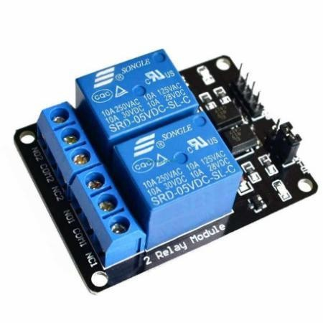

Blynk

Blynk is an Internet-of-Things platform designed to make development and implementation of smart IoT devices quick and easy. It can be used to read, store, and visualize sensor data and control hardware remotely.
Internet of Things has been all the buzz lately and more and more devices are being talking to internet every day. With the rise of such amazing technology, the risk of security has also increased substantially. Some of the major concerns in IoT are:
  - If IoT devices are sending your data to the internet, the communication needs to be closed and encrypted which cannot be possible without using a dedicated and closed server which is really hard to manage.
  - The IoT devices also need to be responsive and again, that is not possible without a server with low latency and high responsiveness.
  - In IoT, the platform needs to be compatible with many different types of hardware architecture and devices, so that it doesn’t restrict its users with single type of hardware with limited capabilities.

Blynk Server – The most amazing component of the Blynk Platform which makes it all possible is the Blynk Server. Blynk offers a secure, responsive and centralized cloud service through its server which allows all of this communication between the devices. The Blynk server is also available as open source so you can literally make your own server and make it even more secure with a little tinkering.

Blynk Library – The key feature of Blynk platform which makes it scalable and amazing, is the Blynk Library. The Blynk Library makes it possible to connect your hardware and get it up and running in a blink. The support for multiple hardware devices including Arduino, ESP8266 and Raspberry Pi is included in the library and it also makes it possible to connect with hardware through many different ways of communication like Wi-Fi, Bluetooth, BLE, USB and GSM.

CONFIGURING BLYNK

After the user installs the Blynk app on the smartphone, an account has to be created in the app to access its services. The first time the app is opened, it will ask to either sign in or create an account. Create an account and add a new project to get started. Each project has its own authentication code which is used by the code to communicate with that particular model. To interface with our components, we need to add widgets to our model. To add widgets press „+” to add to the model. The app provides a neat interface to add all the required widgets and setting them up according to the code. The Blynk needs to be running in the background for the user to get real time notifications.
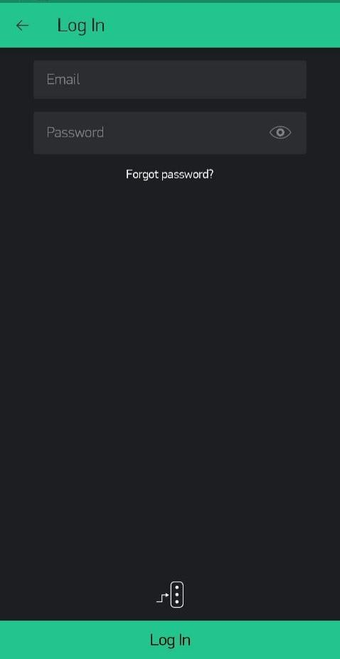
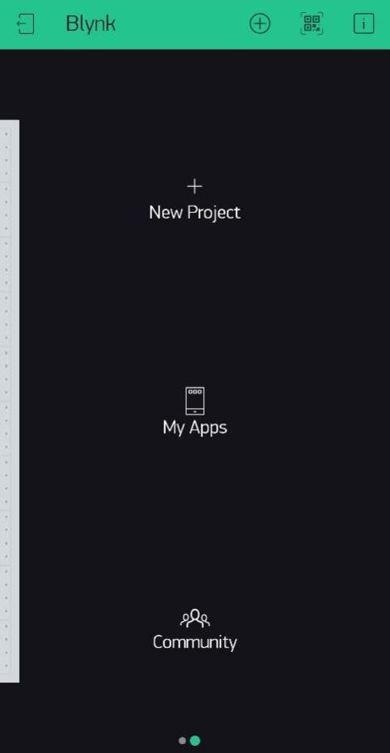

ADVANTAGES

- The main advantage of “Home Automation through Android mobile” is that the “physically challenged and disabled people”.
- Saves electricity
- Quick response
- Can control home appliances from anywhere from the world
- Helps for safety purpose
- If needed we can be notified by a message
- Monitoring 24/7

- Improved citizen's quality of life

Healthcare from anywhere
Better safety, security and productivity

- New business opportunities

IoT can be used in every vertical for improving the efficiency Creates new businesses, and new and better jobs

- Economical growth

Billions of dollars in savings and new services

- Better environment

Saves natural resources and trees
Helps in creating a smart, greener and sustainable planet

- Improved competitiveness

Competitive in providing cutting edge products/services

DISADVANTAGES

- Security: As the IoT systems are interconnected and communicate over networks. The system offers little control despite any security measures, and it can be lead the various kinds of network attacks.

- Privacy: Even without the active participation on the user, the IoT system provides substantial personal data in maximum detail.

- Complexity: The designing, developing, and maintaining and enabling the large technology to IoT system is quite complicated.

REQUIREMENTS
  - Software Requirements :
    - Arduino IDE
You will be needing Arduino IDE software to write and upload the programming logic onto the Arduino Uno board
    - Blynk App
Also, you need to create an account in the Blynk app IoT to integrate the working of the system physically on the Blynk app

Hardware Requirements :
    - Power Supply Board
    - 2 Channel Relay
    - Node MCU (ESP8266)

11. Project Implementation

- An application is installed in the mobile (Blynk).
- ESP8266 Wi-Fi module used for providing communication between the application and system
- By using this we can switch on or off the lights or fans automatically when we are outside
- Also the notification gets triggered in Blynk app whenever a motion is detected

Source Code

/* Comment this out to disable prints and save space */ #define BLYNK_PRINT Serial
#include <ESP8266WiFi.h> #include <BlynkSimpleEsp8266.h>

// You should get Auth Token in the Blynk App.
// Go to the Project Settings (nut icon).
char auth[] = "2301f2e9572a41aeb096fe4bb31a3fa6";

// Your WiFi credentials.
// Set password to "" for open networks. char ssid[] = "Questease Solutions"; char pass[] = "Fareeha08";

void setup()
{
// Debug console Serial.begin(9600); Blynk.begin(auth, ssid, pass);
// You can also specify server:
//Blynk.begin(auth, ssid, pass, "blynk-cloud.com", 80);
//Blynk.begin(auth, ssid, pass, IPAddress(192,168,1,100), 8080);
}
void loop()
{
Blynk.run();
}
void setup() {

// put your setup code here, to run once: pinMode(D4,OUTPUT); .
}

void loop() {
// put your main code here, to run repeatedly: digitalWrite(D4,HIGH);
delay(5000); digitalWrite(D4,LOW); delay(5000);
}
void setup() {
// put your setup code here, to run once: pinMode(5,OUTPUT); pinMode(7,OUTPUT); pinMode(9,OUTPUT);

}

void loop() {
// put your main code here, to run repeatedly: digitalWrite(5,HIGH);
delay(5000); digitalWrite(5,LOW); delay(5000); digitalWrite(7,HIGH); delay(500); digitalWrite(7,LOW); delay(500); digitalWrite(7,HIGH); delay(500);

digitalWrite(7,LOW); delay(500); digitalWrite(7,HIGH); delay(500); digitalWrite(7,LOW); delay(500); digitalWrite(7,HIGH); delay(500); digitalWrite(7,LOW); delay(500); digitalWrite(9,HIGH); delay(5000); digitalWrite(9,LOW); delay(5000);
}

CIRCUIT CONNECTIONS
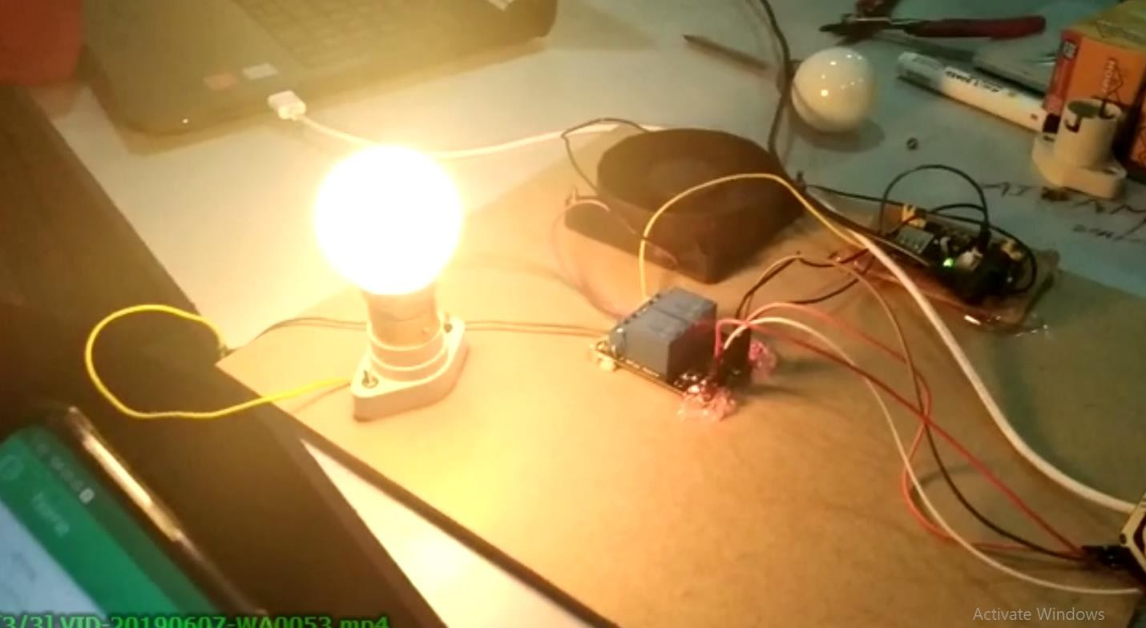

  - OUTPUT

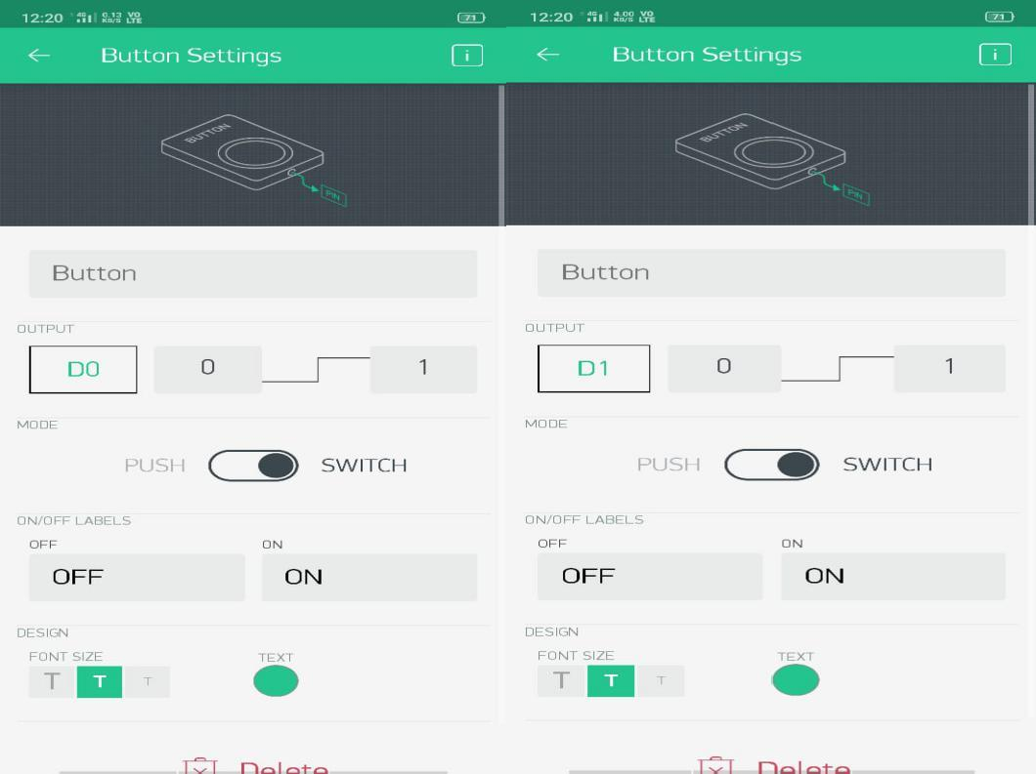

  - CONCLUSION

The project “IOT BASED HOME AUTOMATION SYSTEM” has been successfully designed and tested. Integrating features of all the hardware components used have developed it. Presence of every module has been reasoned out and placed carefully thus contributing to the best working of the unit. Secondly, using highly advanced IC’s and with the help of growing technology the project has been successfully implemented.

Embedded systems are emerging as a technology with high potential. In the past decades microprocessor based embedded system ruled the market. The last decade witnessed the revolution of Microcontroller based embedded systems. With regards to the requirements gathered the manual work and the complexity in counting can be achieved with the help of electronic devices.

BIBLIOGRAPHY

The following books are referred during the analysis and execution phase of the project
- THE INTERNET OF THINGS by Samuel Greengard.
- GETTING STARTED WITH INTERNET OF THING by Cuno Pfister

REFERENCES :

List of Sample IOT Projects:
- https://electronicsforu.com/iot-projects-ideas
- https://www.skyfilabs.com/blog/best-iot-projects-using-arduino

Arduino download:
- https://www.arduino.cc/

Basic Electronic Components:
- https://circuitdigest.com/arduino-projects

